Data Protection Impact Assessment Template

Introduction and Background
What is a DPIA and why is it necessary?
The DPIA is a tool which is designed to identify, assess and manage data and privacy risks as part of any programme/project/change activity. This will enable those conducting the 'change' to consider and build in the necessary privacy and data protection controls from outset, allowing us to meet our regulatory obligations, deliver the best outcomes for our patients and staff and safeguard their rights and freedoms.
The requirement for such an assessment is a mandatory obligation under the General Data Protection Regulation (GDPR) which came into force in May 2018, where any processing of personal information likely to result in a high risk to an individual, must carry out an assessment of the potential impact.
By completing the DPIA in the very early stages of a project, it will allow any privacy risks to be identified at a point in which controls can be put in place to effectively manage these. If a DPIA isn't completed, then it could lead to non-compliant processes and/or systems being implemented, resulting in us facing significant fines from the Information Commissioner’s Office (ICO).
This DPIA is not exclusive to programmes/ projects/change going through formal project governance, but to any change conducted in the business, such as a change to a process, developing a new process, etc.
To summarise, there are five key reasons for completing a DPIA:
1. To identify and manage data and privacy risks for all "change" activity;
2. To avoid unnecessary costs that could be incurred after the change is complete due to unidentified areas of non-compliance;
3. To avoid inadequate solutions to data protection risks;
4. To avoid loss of trust and reputation of our patients/employees (including our colleagues if the change is occurring in HR);
5. To meet our regulatory requirements

DPIA TEMPLATE, PROCESS AND STRUCTURE
The DPIA takes a tiered, risk and outcomes based approach. It's been designed in such a way that dependant on how certain questions are answered, you may not have to complete all stages of the DPIA. There is guidance on each stage of the DPIA which explains who is expected to complete it and provides instructions as to when sign off is required and by whom. All questions should be answered accurately and to the best of your knowledge. A glossary of terms has been added to provide more information relating to some of the terms referred to in the DPIA.
Stages of the DPIA

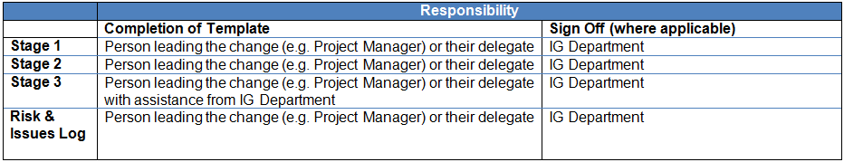

Stage 1: Programme and Data Capture
1. Programme Name | SAFER
2. Programme Ref No (if applicable)
3. Programme Manager Name(s) | Ed Manley, Moira Spyer
4. Division & Department leading the Programme
5. Other areas impacted by the change (where applicable)
6. Project sponsor(s)/Accountable Executive(s) | MRC / UCL / Simon Knight
7. Date DPIA Commenced | June 2020
8. Information Asset Owner(s) | Simon Knight
8. List the main outcomes of the programme including any key milestones | This work is a sub-component of the SAFER/AMR Hub project, which aims to understand nosocomial virus transmission, and the healthcare worker behaviours that mitigate it. In this part of the project, we will use existing data collected on patients and staff movement and interactions within the hospital to track viral transmission. To achieve this, this part of the work has three aims:  - To establish networks of interaction between staff and patients within the hospital, based on proximity and clinical engagement;  - To identify virus transmission pathways involving staff, patients, or both;  - To establish the clinical scenarios, spatial locations, staffing patterns, and broader conditions under which there is a higher risk of virus transmission.  We propose to analyse existing EHR and staff records data to reconstruct patterns of movement and interaction, and by adding disease testing status data, to track back cases of possible nosocomial viral transmission. To achieve this, we require access to data on interactions from EHR data, and movements from staff card access logs and working rotas. As such, personal data will be collected in the form of rough location data within the hospital and testing status data. All data will be analysed within the UCLH network, and not processed elsewhere. All individuals will be pseudonymised, with all personal identifying information removed except for a singular linking identifier.  This work also covers the research wing of the project.
Expected Delivery Date | 31/10/2026
Will the programme involve the processing of/have any impact on personal information about patients and/or colleagues? | Yes, health and within hospital location data of staff and patients
How many individuals will be impacted by the programme? | All staff (~9000) and patients at UCLH.

Stage 2: Risk assessment
This section relates to the risk assessment with regards data protection and the need to conduct the DPIA.
1. Will the programme involve the collection of new information about individuals? No
2. Will the programme compel individuals to provide information about themselves? No

3. Will information about individuals be disclosed to organisations or people who have not previously had routine access to the information? Yes
4. Are you using information about individuals for a purpose it is not currently used for, or in a way it is not currently used? Yes, the data will be used to reconstruct the spatial movements of staff within the hospital and their interactions with patients and other staff.

5. Does the programme involve using new technology which might be perceived as being privacy intruding for example biometrics or facial recognition? No, the data will be derived from the existing and routinely collected electronic records (EPIC, E-Roster, Card access logs).

6. Will the programme result in you making decisions or taking action about individuals in ways which could have a significant impact on them? No, but the results will be used for other hospital wide service planning and management to prevent nosocomial infections.

7. Is the information about individuals of a kind particularly likely to raise privacy concerns or expectations? For example health records, criminal records, or other information that people are likely to consider as private? Yes, health records.

8. transfer data outside of the EEA? No
9. Result in the personal information being processed, including stored by a third party supplier? No

Stage 3: Compliance Check
Please insert a data flow diagram and narrative discussion here:
Figure below shows the construction of datasets within UCLH for this project. Data will be stored within secure environment within UCLH. Transfers will follow to UCL Data Safe Haven, and will be clarified at a later stage.
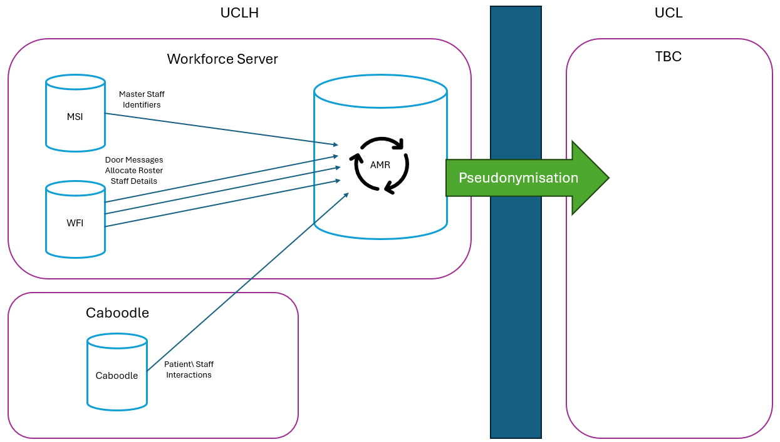

Section 1

Personal information must be processed lawfully, fairly and in a transparent manner

Expected Outcomes
a) Data Subjects will be provided with the appropriate transparency notice / information leaflet wording at the point we collect their personal information. Please liaise with the JRO, IG Office and / or Marketing to ensure the most up to date wording is being used
RESPONSE: No, data from existing electronic records will be processed and anonymised by UCLH data managers before being used for analysis by (honorary UCLH) researchers, and so personal information will not be accessible.
b) Any processing of personal information that your project/initiative is looking to do, should be accurately reflected in the standard Transparency Wording.
RESPONSE: As above

c) The Transparency must be prominent and kept separate from the terms and conditions etc.
RESPONSE: As above

d) In order to ensure that we are collecting and processing the personal information lawfully, we must be able to rely on one of the following conditions to justify why it's needed. This will be our legal basis for processing it.
Please select the appropriate legal basis by clicking on the appropriate option from the list below. If no legal basis can be found, the processing of personal information cannot be conducted:
The individual has given their consent to allow us to process their personal information for a specific purpose(s)
RESPONSE:

The processing of personal information is necessary to facilitate a contract for an individual(s)
RESPONSE:

UCLH has a legal obligation that it must fulfil
RESPONSE:

We are required to process the personal information in order to protect the vital interests of the individual
RESPONSE:

The processing is necessary to fulfil a task carried out in the public interest or in the exercise of fulfilling a request from an official authority
RESPONSE: Yes, the processing of the data will support the development of novel infection control methods to deal specifically with nosocomial transmission of COVID-19. Risks to personal freedoms will be mitigated through anonymisation of data, ensuring no individual is identifiable.

The processing is in UCLH's (or a third party acting on our behalf) legitimate interests, but only where such interests do no override the interests or fundamental rights and freedoms of the individual, in particular where the data subject is a child
RESPONSE:

e) In order to ensure that we are collecting and processing special categories of personal information lawfully, we must be able to rely on one of the following conditions to justify why it's needed. This will be our legal basis for processing it.
Please select the appropriate legal basis by clicking on the appropriate option from the list below. If no legal basis can be found, the processing of special categories of personal information cannot be conducted:
The individual has given their explicit consent to allow us to process their special categories of personal information for a specific purpose(s)
RESPONSE:
The processing is necessary for the purposes of carrying out the obligations and exercising specific rights of UCLH or the individual in the field of employment and social security and social protection law
RESPONSE:

Processing is necessary to protect the vital interests of the data subject or of another natural person where the data subject is physically or legally incapable of giving consent
RESPONSE:

Processing relates to personal information which are manifestly made public by the individual.
RESPONSE:

Processing is necessary for the establishment, exercise or defence of legal claims or whenever courts are acting in their judicial capacity
RESPONSE:

Processing is necessary for reasons of substantial public interest
RESPONSE: Yes, to support the identification of nosocomial transmission, we require an understanding of the testing status of the individuals involved and data on their movements within the hospital. Again, these data will be pseudonymised to the individual. However, the processing of this data will provide insights into the nature of interactions that increase COVID-19 transmission, and thus can be argued to be within the public interest.

Processing is necessary for the assessment of the working capacity of the employee.
RESPONSE:

Section 2

Personal information must be collected for specified, explicit and legitimate purposes and not further processed in a manner that is incompatible with those purposes

Expected Outcomes
RESPONSE: We will pseudonymise all individual data and not attempt to re-identify through combination of datasets.

Section 3

Personal information must be adequate, relevant and limited to what is necessary in relation to the purposes for which they are processed (‘data minimisation’)

Expected Outcomes
RESPONSE: We will collect minimal data about individuals - relating to an anonymised identifier, test status, the location, time and clinical interaction type of patient-staff interactions as recorded by EPIC, and within hospital movements of staff as recorded by the EPIC, E-roster and card access log systems.

Section 4

Personal information must be accurate and, where necessary kept up to date; every reasonable step must be taken to ensure that personal data that are inaccurate, having regard to the purposes for which they are processed, are erased or rectified without delay (‘accuracy’)

Expected Outcomes
The personal information that we hold in respect of our patients and employees must be accurate. Where any anomalies are found, either self detected or via the individual themselves, we have the capability and processes in place to rectify these without undue delay.
RESPONSE:

Quality controls are in place to ensure that personal information recorded is accurate (e.g when migrating personal information from one system to another, bulk uploads) and can be amended if any inaccuracies are detected.
RESPONSE: Data will be drawn directly from the UCLH databases. Data will be handled within the UCLH network via EMAP. This will include data extracted from the card access systems (CCure, Salto), the e-Rostering database, the EPIC (electronic healthcare records system), and electronic staff records. The data will be used to reconstruct staff trajectories and interactions.

Section 5

Personal information must be kept in a form which permits identification of data subjects for no longer than is necessary for the purposes for which the personal data are processed
Where you are looking to implement a new system/platform, it must have the technical capability to apply the deletion rules to ensure that personal information is deleted in line with UCLH Retention Schedule.
RESPONSE: N/A

If you're looking to retain personal information past it's retention period (i.e. past the retention period detailed within UCLH retention schedule), and there is no legal obligation to further retain the data, the information should be pseudonymised/anonymised so that the individual can no longer be identified.
RESPONSE: The data will be anonymised by UCLH data controllers and archived by UCLH as per research governance requirements and standard UCLH policies.

Section 6

Personal information must be processed in a manner that ensures appropriate security of the personal data, including protection against unauthorised or unlawful processing and against accidental loss, destruction or damage, using appropriate technical or organisational measures (‘integrity and confidentiality’)
The project should consult with the Solutions Architect to ensure that controls in line with UCLH Information Security Policy are adopted/in place. Details of the organisational and security measures taken should be provided in the 'outcomes met' column. This includes where other risk assessment has been undertaken by the project or other risk management processes. Details of how you expect that compliance will be checked periodically should also be added.
RESPONSE: All processing will be conducted within the UCLH network (which restricts external access) and accessed only by UCLH employees using appropriate credentials and passwords. Analysis will also be conducted within the UCLH network, by academic researchers working with honorary UCLH contracts.

Where personal information is to be transferred to/shared with a third party supplier, you have consulted with the UCLH Information Governance Team to ensure that an agreement, containing all the standard Data Protection clauses, is (put) in place.
RESPONSE: Data will not be transferred to a third party

Section 7

Personal information can only be transferred to a country outside of the EEA where the appropriate controls have been put in place.
Where personal information belonging to our customers and/or colleagues is to be processed/transferred outside of the EEA (e.g. India, US), the following contractual conditions must be met:
Contracts put in place with the relevant parties and include either:
- The standard EU model clauses; or
- Approved Binding Corporate Rules (BCRs) - for transfers inter-group (where applicable)
RESPONSE: Data will not be transferred

The Procurement Team and UCLH Information Governance Team have been consulted and involved in contract negotiations
RESPONSE:

Where personal information will be transferred to a third party supplier/vendor, the contractual clauses should include provisions covering the onward transmission to additional third parties or countries outside of the EEA.
RESPONSE: Data will not be transferred

Section 8

Personal information will be processed in accordance with individual's rights
GENERAL RESPONSE:

Processes and systems are in place to capture patient/colleague's marketing preferences via all channels (i.e. mail, phone, SMS, email) at on-boarding stage and throughout their relationship with us.
RESPONSE: N/A

If the project is looking to introduce an automated decision making process (i.e. where decisions are made solely by a system or programme which can significantly impact an individual), it must also have the capability for decisions to be reviewed and reassessed manually where required.
RESPONSE: N/A

Where personal information is to be collected and/or stored on a new system, it must have the capability to easily retrieve the customer or colleagues personal information in the event of a subject access request (SAR) being made.
RESPONSE: N/A

There are processes in place to rectify any inaccurate personal information on the request of the individual without undue delay.
RESPONSE: Data will be drawn from existing data sources with these measures in place.

There are processes in place to ensure that data subjects contact the Data Protection Officer with regards their rights and questions about data processing, including complaints.
RESPONSE: UCLH Privacy policy

GUIDANCE NOTES:
The sign-off below is mandatory and must be signed off by the Project Manager/Person leading the change, along with the Project Sponsor/Accountable Executive and the Data Protection Team.
Mandatory DPIA Sign Off
By providing your sign off, you are confirming that you have reviewed the above, are satisfied and agree with the responses provided, and where any gaps have been identified (i.e. not meeting the expectations detailed above) that the required actions to address and remediate these risks have been captured, either in the Risk & Issues log and will be tracked through to completion by the project.
This should be signed off by the Project Manager (or person leading the change) along with the Project Sponsor/Accountable Executive and Information Governence Team. The project sponsor/accountable executive and IG team should provide their sign off via email and a copy kept with the PIA for audit purposes. Please keep a copy of this PIA document with your project documentation.
 |  |  |  | Project Manager/Person Leading Change | Project Sponsor/Accountable Executive | Data Protection Team
 | Name
 | Division/Department
 | Email Address
 | Date Sign off

Risk Logs
We list in the table below risks to Data Protection compliance that have been identified through this DPIA.
Risks & Action Log
Risk Ref No | Risk Title | Risk Description | Agreed Action to Remediate | Owner | Due Date | Status | Date closed | Commentary
SFR0001 | Snooping concerns | Staff may be concerned that their movements are being tracked for purposes of the study including their performance and behaviours. It is important to get a sense of where the areas of infection are and break rooms are a key area. | This needs to be expressly refuted and forbidden in the protocol or information leaflets and uses of data by any UCL H or research staff |  |  |  |  | UCLH Privacy info for COVID, poster and all staff communications
SFR0002 | Patient privacy anxieties | Patients may be concerned that their time in hospital is being monitored for purposes other than their care | Information leaflets and privacy notices should be updated
SFR0003 | Opt out concerns | Patients and staff may not be able to opt out of the monitoring wing of this particular initiative even though staff are allowed to opt out from the research study | Is there a way to ensure that data is not processed where people whether they are staff or patients have indicated a desire to opt out of the study?
SFR0004 | Tracking and other data accuracy and representation | Is the tracking data likely to be reliable? | It’s maybe worth checking this on a routine ward round and have members of staff reporting that the movement was accurate. Are the use of Rovers helpful here?

DATA PRIVACY IMPACT ASSESSMENT - GLOSSARY OF TERMS
UCLH Retention Schedule | Privacy legislation states that personal information shouldn't be held for any longer than necessary, i.e. once we have no legal or regulatory obligation to retain the information, it shoud be securely destroyed. To enable AUK to comply with this obligation, a Retention Schedule was created that lists the specific retention periods dependant on the type of records held. This can be found here (link still to be added).
Data Protection Team | UCLH has a dedicated data protection team. They act as a single point of contact for all data protection matters, they promote best practice, share knowledge and provide guidance to the business. They will review, support and sign off the DPIA at stage 3. They can be contacted at UCLH.IGQueries@nhs.net
EEA Countries (and other countries deemed adequate) | The EEA countries are currently the EU countries (below) plus Iceland, Liechtenstein and Norway:  Austria Germany Malta United Kingdom  Belgium Greece Netherlands  Bulgaria Hungary Norway  Croatia Iceland Poland  Cyprus Ireland Portugal  Czech Republic Italy Romania  Denmark Latvia Slovakia  Estonia Liechtenstein Slovenia  Finland Lithuania Spain  France Luxembourg Sweden  Along with countries based in the EEA, there are some addtional countries deem to have an adequate level of protection for personal information. These are:  Andorra Guernsey New Zealand  Argentina Isle of Man Switzerland  Canada Israel Uruguay  Faroe Islands Jersey
GDPR | The General Data Protection Legislation - this will replace the existing Data Protection Act 1998. It's was introduced to harmonise privacy laws across the EU and came into affect in May 2018.
Personal Information | Personal information is any information relating to an identified or identifiable person. Where an identifiable person is someone who can be identified, directly or indirectly, in particular by reference to an identifier such as a name, an identification number, location data, an online identifier. Examples of personal information include, but are not limited to:  - Name  - Address  - Date of birth  - NHS Number  - NI Number  - Email address  - Policy number  - Health data  - Biometric or genetic data  - IP address  - Location data  There is a sub-set of personal information knows as 'Special catagories of personal information' (see definition below) which requires additional controls due to the sensitive nature of the information.
PIA | Privacy Impact Assessment (PIA) - was a voluntary process designed to identify, assess and manage Data Privacy risks as part of any project/change/initiative under the Data Protection Directive 1995 and the Data Protection Act 1998. It has been superseded by the mandatory Data Protection Impact Assessments under the General Data Protection Regulation.
Processing/process | Processing means any action we undertake with personal information.  This includes, for example:  - collecting the information  - recording the information  - storing/retaining the information  - retrieving the information  - using the information  - disclosing/transferring the information  - altering the information  - deleting/detroying the information
Project Sponsor/Accountable Executive | This is typically a senior person within the business area that will receive the business outcomes and benefits from the project and not part of the project delivery team.
Pseudonymisation/anonymisation | Pseudonymisation is a procedure by which the most identifying fields within a data record are replaced by one or more artificial identifiers, or pseudonyms. There can be a single pseudonym for a collection of replaced fields or a pseudonym per replaced field. The purpose is to render the data record less identifying and therefore lower individuals objections to its use. Data in this form is suitable for extensive analytics and processing.  Anonymisation is the process of turning data into a form which does not identify individuals and where re-identification is not likely to take place. This allows for a much wider use of the information.
Risk Acceptance process | There are times, when for perfectly legitimate reasons an action to resolve an incident or risk exposure cannot be completed within for example, a reasonable time or cost.  Applying the Risk Acceptance process within UCLH ensures that the risks we choose to accept are formally recorded, that the decision is made with full understanding of the potential impacts, and that these issues are actively resolved through an agreed action plan, fully endorsed by the UCLH governance structure.
Special catagories of personal information | This is a 'sub-set' of personal information and is considered as information that would present a higher risk to an individual if not handled appropriately. Under the DPA this type of information was known as sensitive personal information and relates to data concerning the following:  - health/medical information  - criminal convictions and offences  - racial or ethnic origin  - political opinions  - religious or philosophical beliefs  - trade union membership  - sexual life/orientation  - genetic or biometric information
Third party supplier/vendor | Where a third party means any other organisation or person that is not part of UCLH (e.g. a supplier providing us with IT support, a service provider performing a business process on our behalf (e.g. handling our scanning) or hosting IT systems on our behalf). A third party in this context does not mean an employer of a pension scheme or an adviser.  The third party's involvement could be part of the project lifecycle itself (e.g. for consultancy or support services) but also into BAU (e.g. where they will work on behalf of AUK to support the administration of a new product and will have ongoing access to our information).
Transferring/Sharing personal information with third party suppliers | The 'sharing' of personal information with a third party is not limited to physically or electronically transferring the information to them. It also includes them having remote, viewable access to the information (even if the information still resides with AUK systems/premises).

